**Ideation phase**

**Brainstorm and idea Prioritization Template**

|  |  |
| --- | --- |
| **Date** | 16-10-22 |
| **Team ID** | PNT2022TMID14185 |
| **Project Name** | Smart Farmer-IOT Enabled Smart Farming Application |
| **Maximum marks** | 4 Marks |

**Brainstorm and Idea prioritization Template:**

Reference: https://app.mural.co/t/ashikar6064/m/ashikar6064/1664728229819/e79ac7e870edc9e4d0 862f01767ec312f9c2d1c6?sender=u854e4a823eb1c764ca726390

Step-1: Team Gathering , Collaboration and Select the problem Statement

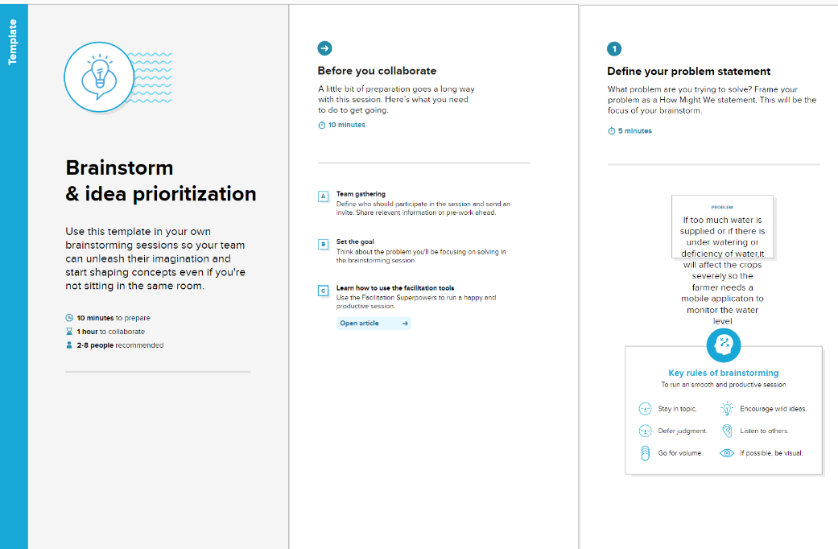

**Step-2: Brainstorm, Idea Listing and Grouping**

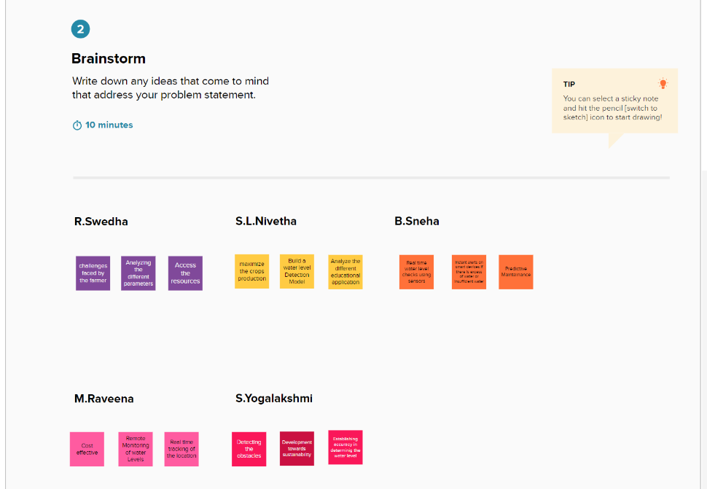

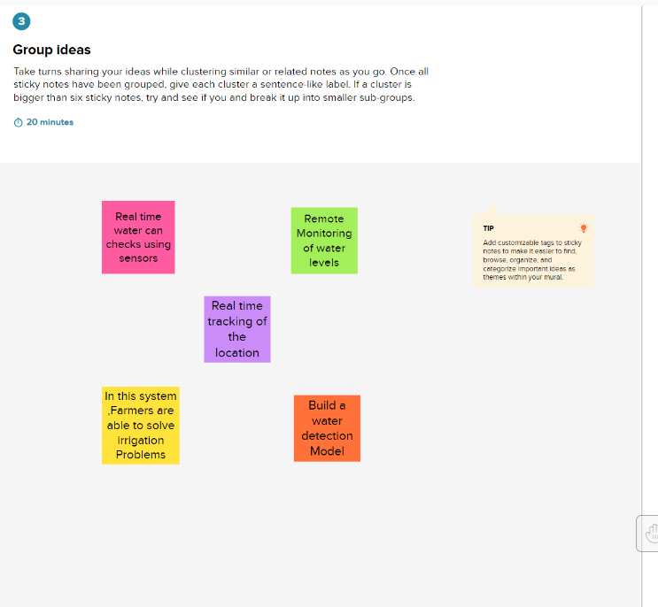

Step-3: Idea Prioritization:

